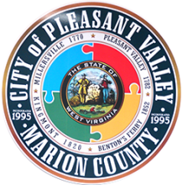 **MINUTES**

**Laying of the Levy Meeting**

**April 19, 2024**

Mayor Haddix called the meeting to order at 7:00pm on April 19, 2024, in Council Chambers at the Municipal Building, 2340 Kingmont Road, Pleasant Valley, WV.

**In attendance:** Emily Haddix, Chip Phillips, Matt Heston, Erin Henderson, Mike Walls, Gary Timms, John Miller, Kim Korcsmaros

**Public in attendance:**

**Absent:** Chuck Ledsome, John Funkhouser

Mayor Haddix presented the Notice of Conditional Approval of the Levy Estimate (Budget).

She also read the levy rates for the fiscal year ending June 30, 2024 that are Class 1, 3.29%; Class2, 6.58%; Class 3 & 4, 13.16%. Emily Haddix noted that the levy in the City of Pleasant Valley is still the lowest in the State of West Virginia.

Emily Haddix called for questions and/or discussion. Being that there was no further discussion or questions on this issue, Mike Walls motioned that the meeting be adjourned. Matt Heston seconded the motion. Motion passed unanimously.

Laying of the Levy (Budget) meeting adjourned at 7:06 p.m.